START PRESENTATION (Thumbs up) | 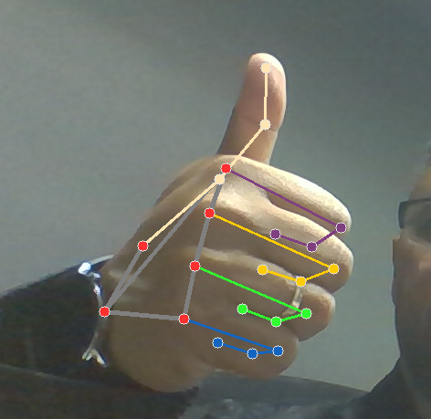
Hold/ PAUSE (Hand with open Palm | 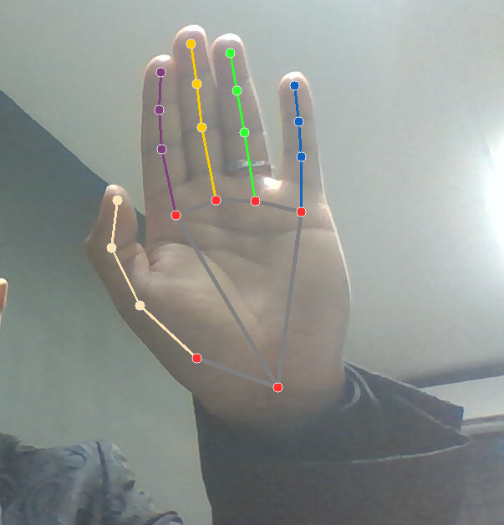
Swipe Left with two fingers (FORWARD Next Slide) | 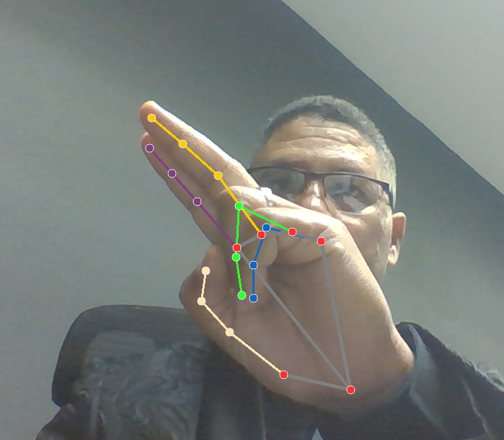
Swipe Right with two fingers (Backward (Previous Slide | 